Configuration Management Plan

Naming Conventions

1) Variables.
- Use of lower- and upper-case to separate words.
- Example: $exampleVariableName

2) Files.
- Use of lower- and upper-case to separate words.
- Example: equipmentScript.php

Directory Structure

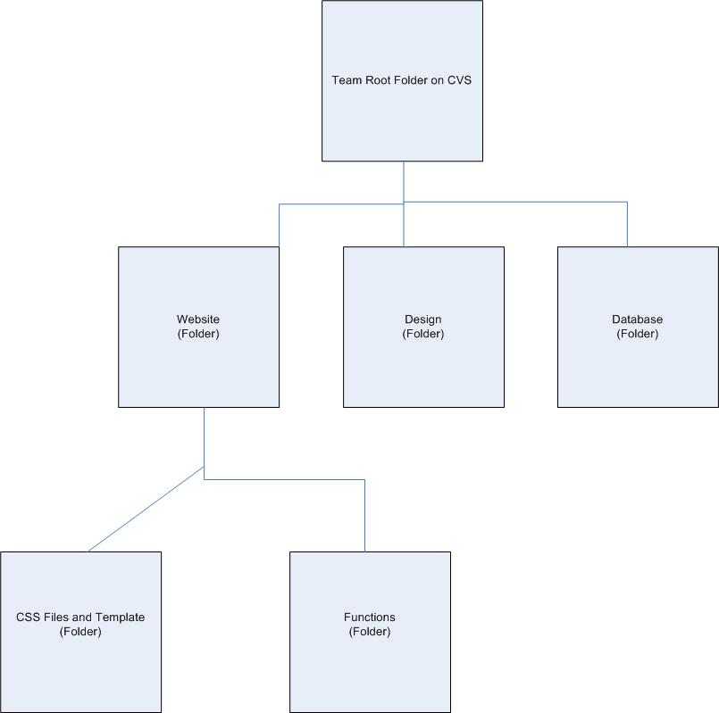

Changing Code Policy

1) Change code on local machine and test before uploading to CVS repository.
2) When working with other team member’s code, comment out old code, do not delete code.
3) Add comments and explanation above any changes.
4) Final approval of code requires original author’s approval and another team member’s approval.

Bug Tracking Plan

(Straw-Man version in separate Excel Sheet named “Team 4 Bug Report”)

We will use the following format for tracking bugs:

Location | Found By | Date | Method | Description | Fixed By | Date Fixed
samplePage.php | Horn | 03 MAR | Inspection | SQL Query to database does not retrieve correct data | Horn | 5 MAR

